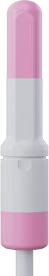
Protocol for Treating Female Sexual Dysfunction (FSD) Using Low-Intensity Shockwaves

Device: MoreNova - Li50F Linear Transducer
Document Version: 1.0
Date: 17/12/25

Purpose and Scope
This protocol provides a standardized treatment plan for using low-intensity shockwaves to manage Female Sexual Dysfunction (FSD). It is intended for healthcare providers using the MoreNova Device with the Li50F Transducer to target the clitoral region, bilateral labia minora, crura, and pubic area.
This protocol applies to women experiencing symptoms of FSD, including low libido, arousal difficulties, or orgasmic dysfunction. For further information on clinical studies and efficacy, visit our Clinical Data Center.
Device Overview:
MoreNova is a portable Electromagnetic (EM) Low-Intensity Shockwave (LISW) device designed to reduce inflammation, dissolve calcifications, and stimulate angiogenesis, improving outcomes for various conditions in men and women.

Introduction
Low-Intensity Extracorporeal Shockwave Therapy (LiESWT) is a non-invasive technology that uses acoustic waves to promote vascularization, enhance blood circulation, and stimulate nerve regeneration. It has been clinically proven to improve sexual function in women by targeting key anatomical areas associated with sexual arousal and response.

Background Condition Overview:
  - Female Sexual Dysfunction encompasses various conditions related to low sexual desire, difficulty achieving arousal, or inability to reach orgasm.
  - It may result from reduced blood flow, nerve dysfunction, hormonal imbalances, or psychological factors.

Mechanism of Action:

  - Low-intensity shockwave therapy stimulates neovascularization and enhances tissue oxygenation in targeted areas.
  - Improved blood flow and nerve sensitivity contribute to better sexual arousal and response.

Patient Selection Criteria Inclusion Criteria:
  - Women aged 20-75 years experiencing symptoms of FSD.
  - Diagnosis of FSD by a gynecologist or sexual health specialist.
  - Persistent symptoms for at least 3 months.

Exclusion Criteria:
  - Active vaginal infections or pelvic inflammatory diseases.
  - Pregnancy or lactation.
  - History of vulvar or pubic area surgery within the past year.
  - The presence of medical implants is sensitive to electromagnetic radiation.
  - Chronic neurological conditions affect the Pelvic region.

Pre-Treatment Screening
To determine the patient's suitability for LiESWT, conduct the following:
  - Comprehensive medical and sexual history review.
  - Physical examination of the genital area.
  - Diagnostic tests: Rule out infections or anatomical abnormalities.

Treatment Protocol Preparation:
  - Conduct a thorough medical history and gynecological examination.
  - Counsel the patient about the procedure, benefits, risks, and expected outcomes.

Procedure:
  - Number of Sessions: 6 sessions
  - Session Frequency: Twice per week.
  - Session Duration: 20 minutes.
  - Applications Per Session: 5 (labia minora - bilateral, clitoris, Crura).
  - Shocks Per Application: 500.
  - Total Shocks Per Session: 2500.

Treatment Parameters:
  - Energy (HV) Settings: 1.9 kV.
  - Frequency (FRQ): 2.0 Hz.

Post-Treatment Care:
  - Advise patients to avoid sexual activity for 24 hours after each session.
  - Recommend hydration and report any adverse events.

Treatment Areas and Techniques
The treatment focuses on the following anatomical areas:
  - Clitoral region.
  - Labia minora (bilateral).
  - Crura

Transducer Placement:
  - Apply the Transducer gently to the designated areas, using conductive gel to facilitate energy transfer.
  - Deliver 500 shocks to each application area, following the predefined sequence.

Patient Comfort and Safety
To ensure patient comfort and safety during the procedure:
  - Position the patient in a lithotomy or supine position for optimal access.
  - Use conductive gel to minimize discomfort and enhance shockwave transmission.
  - Continuously monitor patient feedback during the session.
  - Adjust settings or pause treatment if discomfort is reported.

Treatment Outcomes and Follow-Up
Expected Results:
Patients may notice improvements in sexual arousal and response within 3-6 weeks after starting treatment. Regular assessments are recommended to evaluate progress.

Follow-Up Visits:
Schedule bi-weekly follow-ups during the treatment period to monitor outcomes and address concerns.

Long-Term Maintenance:
Consider scheduling maintenance sessions every 6 months to sustain benefits.

- Visuals and Diagrams Li50F

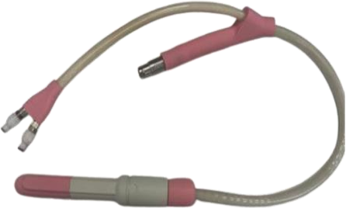

  - Transducer placement technique and anatomical areas targeted (clitoral region, labia, pubic area, Crura).

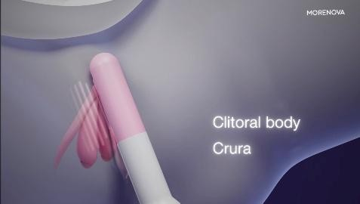
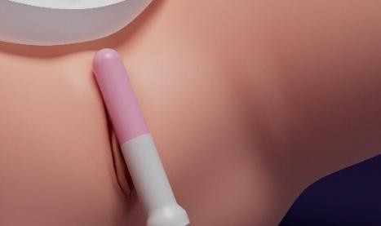
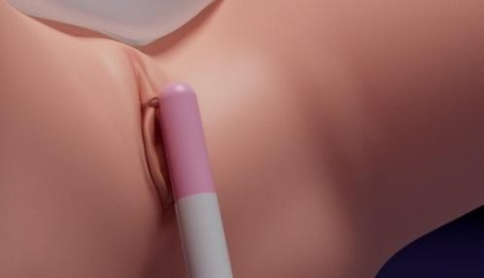

clitoris

Labia minora

- Quality Control Device Calibration:
  - Verify device settings before each session.
  - MoreNova Device recognizes preprogrammed parameters to ensure accuracy.

Clinician Training

Ensure all operators are trained to use the MoreNova Device and the Li50F Transducer.
  - Clinicians should be familiar with this protocol and the "Instructions for Use" provided by the manufacturer.

Checklist for Each Session:
  - Confirm that the patient meets the inclusion criteria and has no contraindications.
  - Ensure the device and Transducer are clean, sanitized, and function correctly.
  - Verify that the Transducer placement aligns with the specified anatomical area.

References
For clinical studies and additional resources, visit the Initia Clinical Data Center.

